Name ……………………………………………………………………… Class: ………………………………… Date / /

Objectives: The students should be able to:
Describe the primary, secondary and tertiary structure of proteins

Activity 1:
1-Write the chemical formula of amino acid

2-Complete the following
a-The ……………………………….of a protein is the sequence of amino acids in the chain.
b-The chains of amino acids form helices and pleated sheets held by ………..this gives the protein its ………
c-The ……………of a protein is the complex three-dimensional shape the molecule takes when the polypeptide helix
twists and folds around itself
d-The function of haemoglobin to pick up………………in the lungs to form……………………
3-Choose the correct answer
a- The chains of amino acids form helices and pleated sheets held by hydrogen bonds this gives the protein its…
( primary structure- secondary structure – tertiary structure )
b- The ……………………………….of a protein is the sequence of amino acids in the chain.
( primary structure- secondary structure – tertiary structure)
HOMEWORK due date next period
1- Write the scientific term for
1-It is the sequence of amino acids in the chain. ( )
2-It is the complex three-dimensional shape the molecule takes when the polypeptide helix twists and folds around itself ( )
3-It is the chains of amino acids form helices and pleated sheets held by hydrogen bonds ( )
توقيع ولى الأمر

4-Draw a simple diagram for phospholipids

5-Describe the structure of phospholipids

6- Write the name of the following drawing
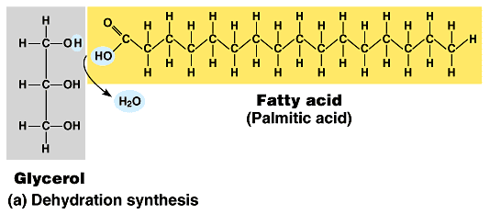

…………………………………………………………………………………………………………………………………………………………………………..

ACTIVIYT 2
1-complete the following statements
a-Lipids include ……………and …………………..
b-At room temperature fats are ………..and ………...
c-Triglycerides consist of one molecule of ………..and three fatty acid molecules
d-Phospholipids are formed of one molecule of ………. , one molecule of ……… and two molecule of ………
e-Examples of lipids are ………… and …………..
II- Choose the correct answer
a-Triglycerides are composed of three fatty acids molecules joined to a molecule of (glycerol-glucose ).
b-At room temperature (fats –oils ) are usually liquids.
c-At room temperature (fats – oils )are usually solids.

HOMEWORK due date next period
a-Lipids include ………..and ………….
b-At room temperature………are solid but……..are liquid and both are lipids
c-Triglycerides consist of one molecule of…………..and three molecules of …………
d-Phospholipids are formed of one molecule of………….,one molecule of………….and two molecules of ……………
2- Write the scientific term for
a-They consist of one molecule of glycerol and three fatty acids molecules ( )
b-They consist of one molecule of glycerol, one molecule of phosphate and two molecules of fatty acids ( )
c-One of the lipids that it is solid at room temperature ( )
d-They are a large and varied group of organic compounds .They include fats and oils ( )
3-Draw a simple diagram for
a-phospholipids
b-A triglyceride

توقيع ولى الأمر

